PAYMENT FORM
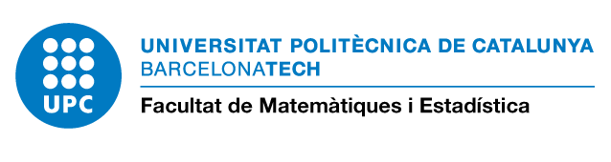
 | MESIO student |  | Other FME Student |  | PhD UPC & UB Student |  | External |  | PDI

PERSONAL DATA
NAME AND SURNAME:
DNI/NIE or passport:  (a copy of the document is needed) |  | Birth date:
E-mail: | Telephone number:
Postal address:
City/Country: |  | Zip code:

ACADEMIC DATA
Course (Mark the courses you want to register) |  |  |  | Course (Mark the courses you want to register)
 | Una Introducción a Spark – Group 1 |  |  |  | Cómo crear aplicaciones con Shiny
 | Una Introducción a Spark – Group 2 |  |  |  | Design aspects of individually randomised trials, cluster […]
 | Applied Generalized Linear Mixed Models with R |  |  |  | Data Science con R: Tidyverse – Group 1
 | Aspectos computacionales de la gestión de riesgo |  |  |  | Data Science con R: Tidyverse – Group 2
 | Python for Data Analysis |  |  |  | Metaanálisis con R
 | Introduction to Network Analysis |  |  |  | Uso solvente de la información
 | Big Data management with R

REGISTRATION PAYMENT | Total amount: €
Take this form by e-mail (acces.mesio.fme@upc.edu) together with a copy of your DNI, NIE or passport.

Bank transfer:
IBAN CODE: ES83 2100 5000 5902 0006 0504 - SWIFT: CAIXESBBXXX
It is essential that you write on the bank transfer reference: U-00809 + name of the student
Invoice:

Company name: |  |  |  |  | NIF:
Address:
City: |  | Postal code: |  | Region:
Country: | Contact person:
Department: |  |  | Telephone number:
E-mail

Charge the amount to the UPC project:

Authorization in charge of the project:
Complete name of the professor responsible for the project:

Project number: |  | Amount: €
Signature of the responsible: | Date:

MESIO Students (old curriculum): Same as the registration payment for the master.

Your personal information will be included in a database under the responsibility of the School of Mathematics and Statistics (UPC) and may be used in order to send information about other activities organized by the center. According to the Organic Law 15/1999 of 13 December on the protection of personal data, you can exercise your right of access, rectification, and opposition and cancellation policy for your data contacting by email to fme.informacio@upc.edu.

